Sprint 8 Status Report
For the Girl Scouts of America Badge Tracking
Application

By
Matt Eck
Michael Glosecki
Nathan Martz
Ryan Schroeder

Of
Team Cookie Council

1. The Council estimated 80 hours to complete sprint 8 however the sprint took us 77 hours. After the sprint was completed we had 10 hours left on the story tasks selected.

2. The focus of this sprint was to get the web pages finished before beta release. The pages all focused around the badge tracking applications and troop management. These pages included:
- MyTroop
- Badge Update
- Journey Update
- Scout Records
- Add Scouts
These pages were worked on individually but before beta integration the pages were worked on by all group members.

3. Client was contacted but with no response for beta release. Server guy was again contacted but with no response.
4. Server risk was addressed but not mitigated.

Project Burndown chart

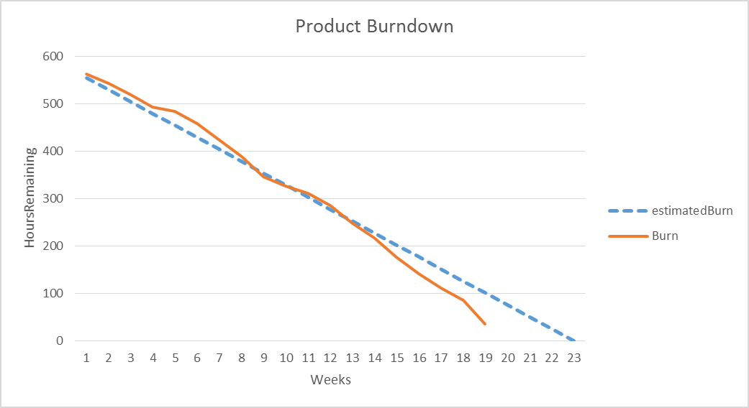

Sprint Burndown Chart

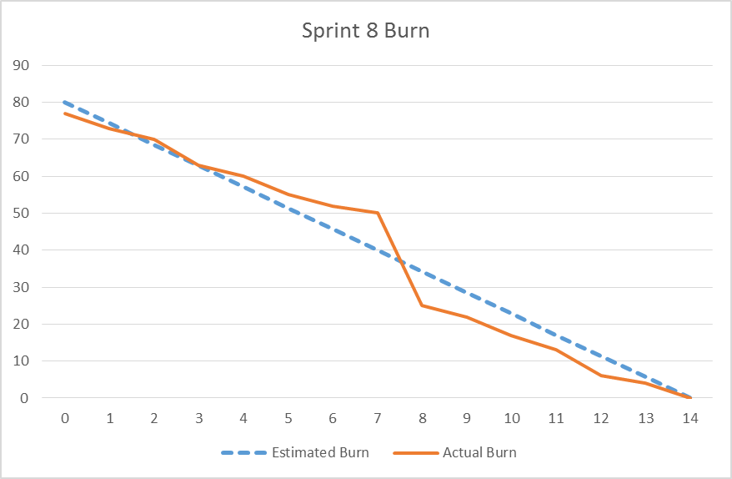

Weekly Development Effort

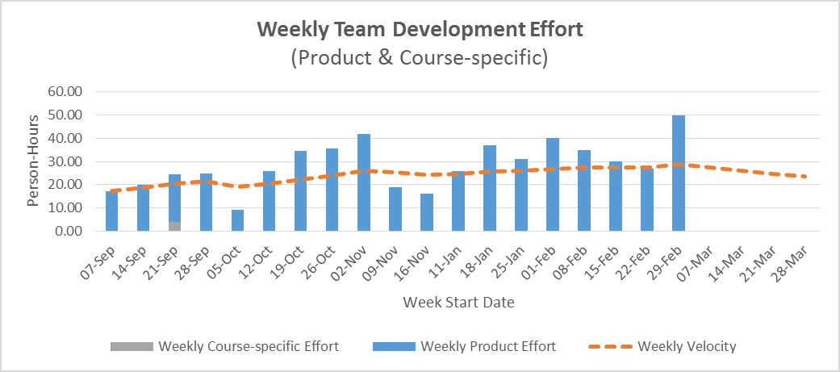

Daily Team Effort

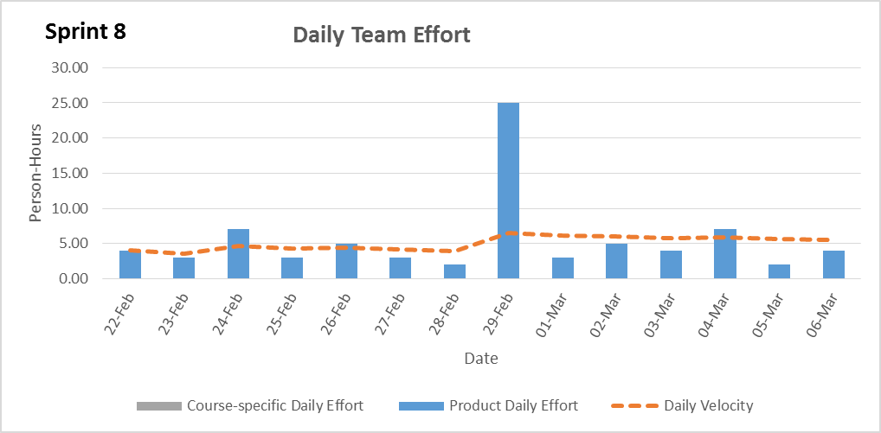

Team Member Effort

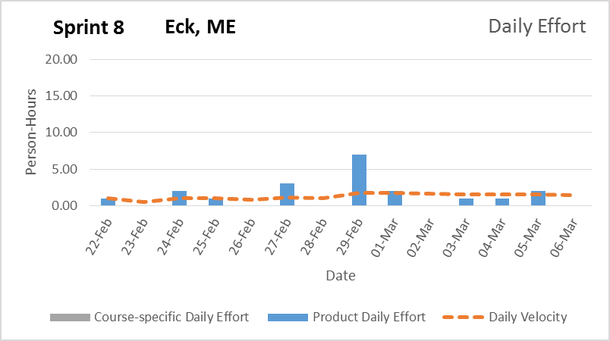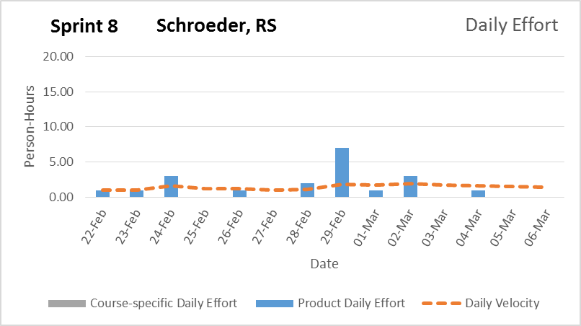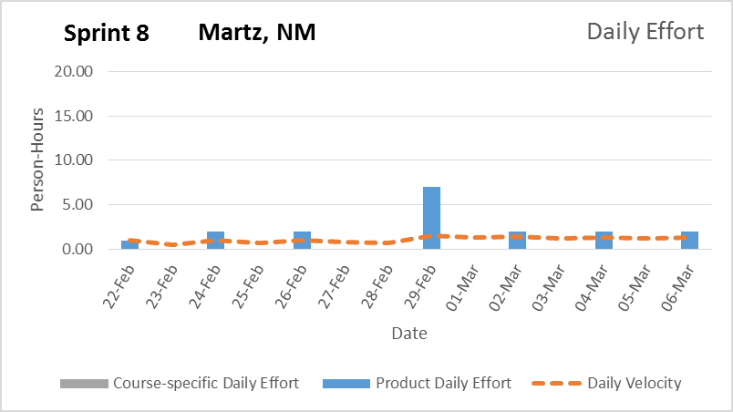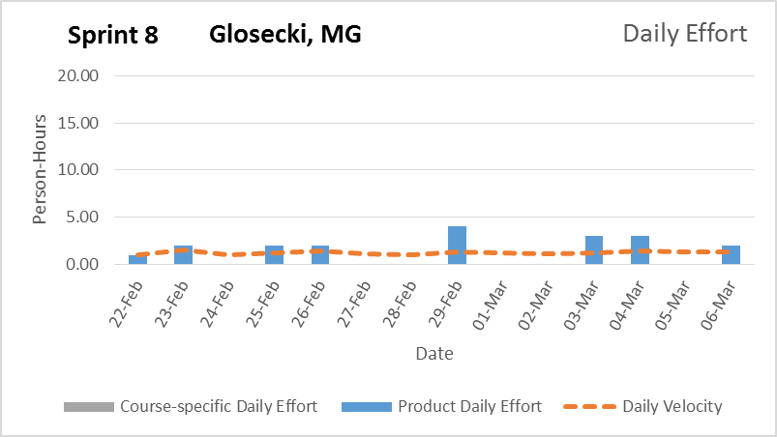

6. The team believes the browser version of this page will be complete with all functionality but the mobile app will be lacking in refinement.

Signature Date

__________________________________________ ______________

__________________________________________ ______________

__________________________________________ ______________

__________________________________________ ______________

